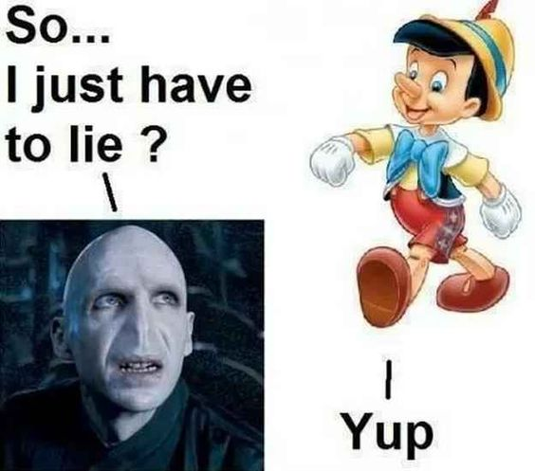**Not the Whole Truth**

Look at the situations below. They all involve a type of lying – not giving the whole truth. Do you think the lies are justifiable? Why or why not?

1. You are the Secretary General of the UN. Top astronomers have just told you that a giant asteroid is coming to destroy Earth. It will be here in a week, and it’s unstoppable. You decide that to tell the human race about this would cause chaos. You decide to keep it a secret in order to allow the people of the world to enjoy its last seven days in peace.

2. Zombie swarms have taken over half of the country. All cities on the east coast have fallen, and the zombies are heading westward towards your city. One idea is to use bait to bring all the zombies into one area, trap them, and kill them easily. As you begin to evacuate the city, you tell 15% of the population to go to a safe area in the eastern part of the city. The other 85% of the people escape to the north, south, and west. The people going east will be used as bait for the zombies and will save the other 85%. The 15% do not know this.

3. You are an anthropologist who has just made an amazing discovery that shows that not all races are equal. Most are the same, but you’ve proven that the Khansan people, a Native American tribe with fewer than 1,000 members, are by far more advanced in intelligence than all other humans, but, due to centuries of discrimination, still live in poverty. You decide not to tell anyone about this discovery because it may lead to even more discrimination.

4. You are a police officer. In your town, which is near the border of another state, is a young man who has been in prison twice. Since getting out, he’s gotten a job and stayed out of trouble for the first time in his life. As part of his parole agreement, he’s not allowed to leave the state. If he does, he’ll have to go back to prison for 10 years. One night, he leaves the state to visit his dying father. You catch him for speeding on his way back home. You let him go and tell your commander that you never saw the young man.

5. The current president is quite popular and is trying to get re-elected. You like her and think she’s done good things for the country, like getting it out of pointless wars, making the economy the best ever, and making major advances in fighting global warming. However, as an elections investigator, you discover that her election three-and-a-half years ago was a mistake. Everyone thinks she barely won by 10,000 votes, but you find out that someone switched the results – she actually lost by 10,000 votes. You decide not to tell anyone to avoid social upheaval or cause the president to lose the election.

6. You are a well-known leader in a major world religion. You are generally respected even by people who don’t share your religion. You have a heart attack and die. While dead, you meet Ra, the chief God of the Ancient Egyptians. He is very angry that no one worships the gods like him anymore and tells you that most people who die these days are eaten by Ammit, the Soul Devourer (basically, Ancient Egyptian hell) because they are not faithful to the Pharaoh. Suddenly, you’re brought back to life by EMT’s. For the next few months, you see visions of Ra, and you begin to believe what he said was true. However, you think no one will believe you, so you say nothing.

This activity copyright 2020 – Nelson Parish

Voldemort & Pinocchio: https://www.pinterest.co.kr/pin/117234396526790167/

**Vocabulary for “Not the Whole Truth”**

|  |  |
| --- | --- |
| **Term** | **Definition** |
| 1. anthropologist (n.) | a. ___ able to be explained as correct; supportable |
| 2. asteroid (n.) | b. ___ change one thing for another thing |
| 3. astronomer (n.) | c. ___, ___ disorder; unpredictability |
| 4. bait (n.) | d. ___ eater |
| 5. chaos (n.) | e. ___ emergency medical technician, or someone who treats sick or injured people before or during their ride to the hospital in an ambulance |
| 6. commander (n.) | f. ___ giant rock in outer space that is the size of a very small planet |
| 7. devourer (n.) | g. ___ going faster than the legal driving limit |
| 8. discrimination (n.) | h. ___ head of an organization made of most of the world’s countries |
| 9. EMT (n.) | i. ___ huge group of creatures moving unpredictably, like hornets or bees |
| 10. investigator (n.) | j. ___ king in Ancient Egypt, who was looked upon as a god |
| 11. justifiable (adj.) | k. ___ leader; chief; boss |
| 12. keep something a secret (v. phrase) | l. ___ meaningless; without reason |
| 13. Native American (proper n.) | m. ___ not tell anyone something |
| 14. parole agreement (n.) | n. ___ person whose ancestors were in North and South America before the Europeans arrived |
| 15. Pharaoh (n. or proper n.) | o. ___ pray to; follow; look up to |
| 16. pointless (adj.) | p. ___ scientist who studies outer space – stars, black holes, etc. |
| 17. Secretary General of the UN (proper n.) | q. ___ small group of people who have similarities in culture, language, etc. |
| 18. speeding (n.) | r. ___ someone who studies humans and their cultures and ancestors |
| 19. swarm (n.) | s. ___ someone who tries to find if a crime has been committed |
| 20. switch (v.) | t. ___ something that attracts something else, often an animal that is being hunted |
| 21. tribe (n.) | u. ___ special set of rules that someone who was in prison must follow for a little while after leaving prison |
| 22. upheaval (n.) | v. ___ treating someone differently because of something that is not their fault |
| 23. worship (v.) |  |

This activity copyright 2020 – Nelson Parish